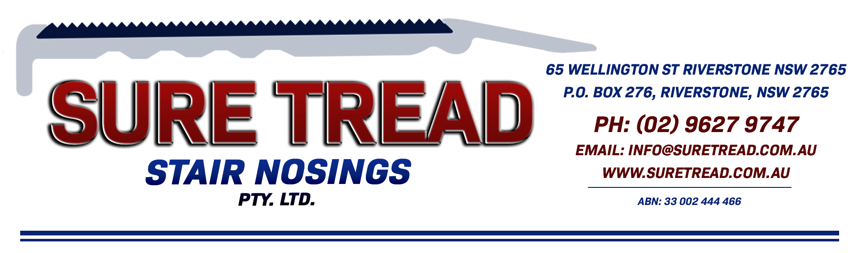

ST 65-3 SN PROFILE SHEET

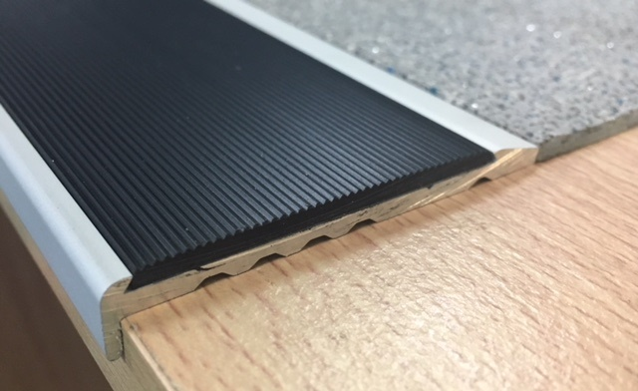

The ST 65-3 SN clear anodised aluminium stair nosing is 65mm on the tread with a 50mm pvc insert and a 10mm riser, it is designed to be fitted in conjunction with 3mm resilient floor coverings.

The nosing is designed to be fitted directly to the sub floor with the floor coverings to butt up to the back of the 3mm nosing on the tread.
The sub floor must be in good condition (smooth, level & clean) and the head of the steps must be square fronted.
If floor coverings are being used on the riser they need to be done and cut flush with the top of the tread prior to the stair nosings being installed.
The floor coverings on the tread must be installed immediately following the installation of the stair nosings otherwise the stair nosings will be a trip hazard.

Alternatively this profile can be recessed into concrete or timber.

End Caps are NOT available.
Drilled at approximately 250mm spacings.
Slip Test Results with PVC insert = P4
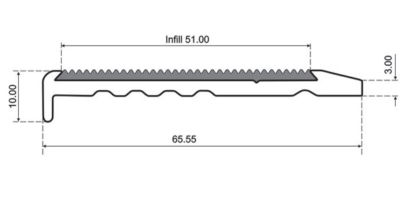
We recommend you seek the certifier’s approval on the profile and insert colour as they all interpret the standards differently.


