ST 65-8 CC PROFILE SHEET

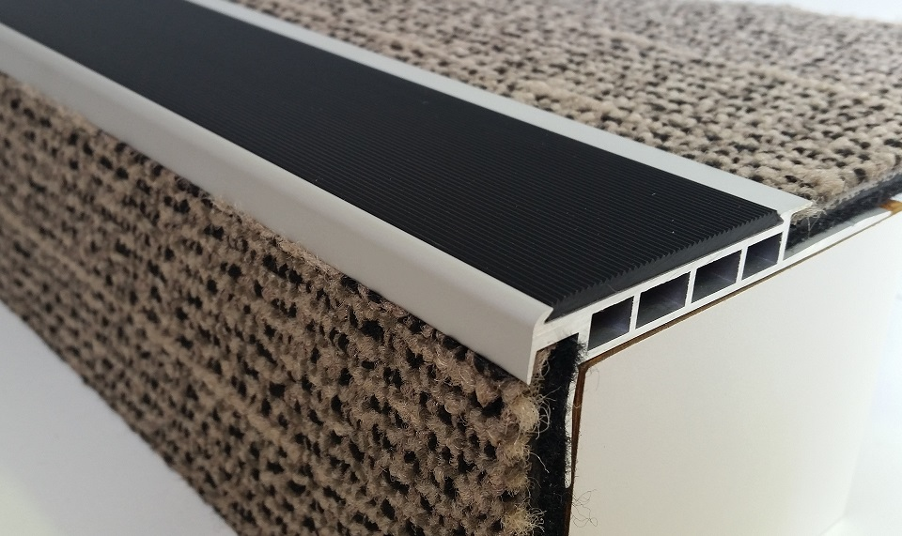

The ST 65-8 CC stair nosing is 65mm on the tread with a 50mm PVC insert and a 10mm visible riser, it is suitable for 8mm carpet.

The nosing is designed to be fitted directly to the sub floor with the floor coverings to be inserted into the back of the 8mm cut out and up the riser to leave 10mm of exposed nosing down the riser.

Drilled at approximately 250mm spacings.

