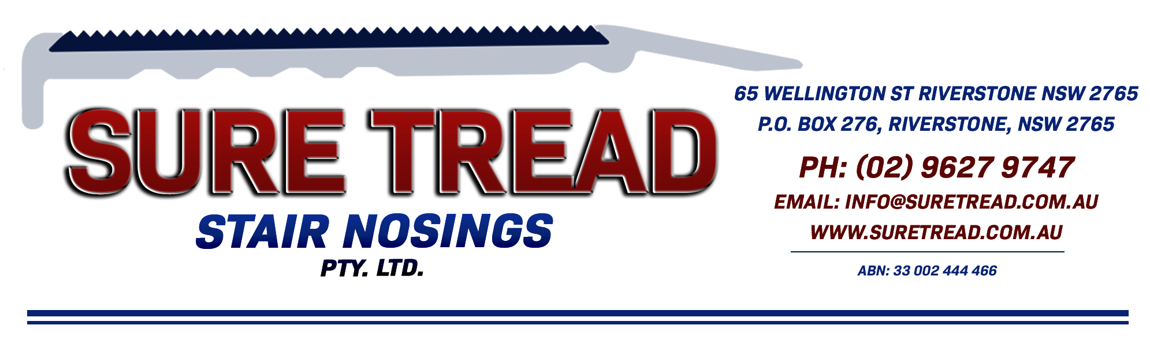
ST 74 PROFILE SHEET

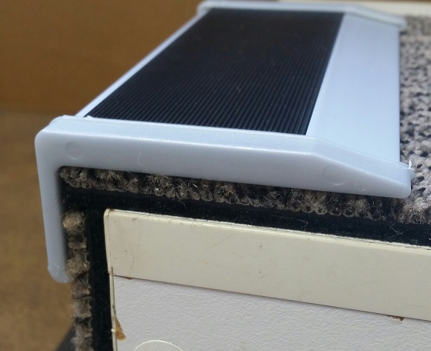

The ST 74 clear anodised aluminium stair nosing is 75mm on the tread with a 50mm pvc insert and a 35mm riser.
Due to the chamfered tail this profile can be fitted direct to concrete or timber as well as floor coverings such as carpet (no underlay), carpet tiles and vinyl.

Drilled at approximately 230mm spacings.
Suitable for internal use only.
Available with or without end caps.
When fitting direct to the sub floor End Caps are not recommended and a zig zag of adhesive should be used (Adhesive NOT supplied for a supply only)
Slip Test Rating = P4
We recommend you seek the certifier’s approval on the profile and insert colour as they all interpret the standards differently.



