ST 76 GT PROFILE SHEET

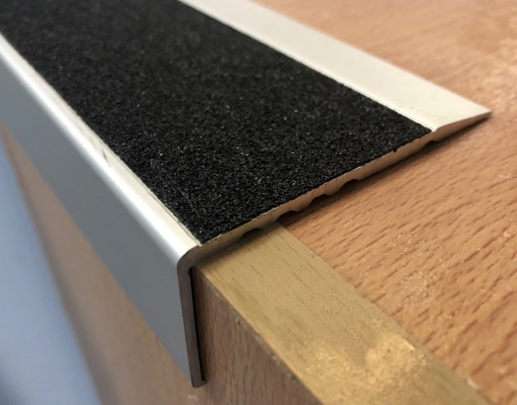

The ST 76 GT clear anodised aluminium stair nosing is 75mm on the thread with a 50mm grip tape and a 33.5mm riser.
The anti-slip tape is constructed of Aluminium Oxide grit bonded with PVC film and coated with an age resistant acrylic adhesive.
The tape has excellent slip resistance and is resistant to water, mild alkaline and acid solutions, detergent in water.

Adhesive to be used under the stair nosing when fitting directly to the subfloor (Adhesive NOT supplied for a supply only)
Designed to be fitted direct to concrete or timber or over resilient floor coverings.
Not suitable for soft floor coverings.

End Caps are NOT available.
Drilled at approximately 250mm spacings or can be supplied in blank form.
Slip Test Rating = P5
We recommend you seek the certifier’s approval on the profile and insert colour as they all interpret the standards differently.
