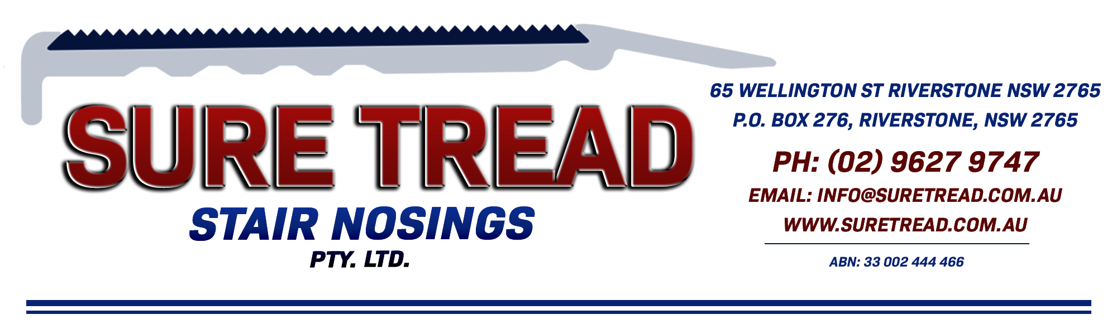
STB 60 - PROFILE SHEET
The STB is a 60mm scalloped solid brass stair nosing.

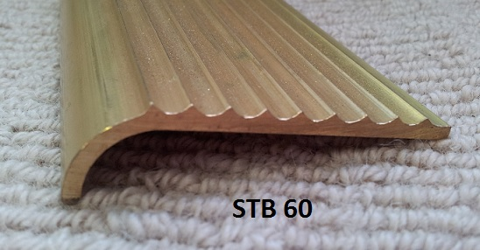

Suitable for most solid bodied carpets (no underlay) or can be fixed direct to the sub floor. Can be drilled and countersunk at 250mm spacings and has exposed fixing with brass plated screw.
Standard extruded finish.
Slip Rating = P5
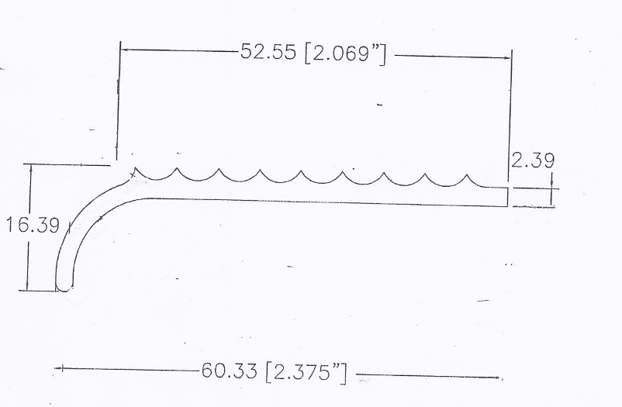
We recommend you seek the certifier’s approval on the profile and insert colour as they all interpret the standards differently.

