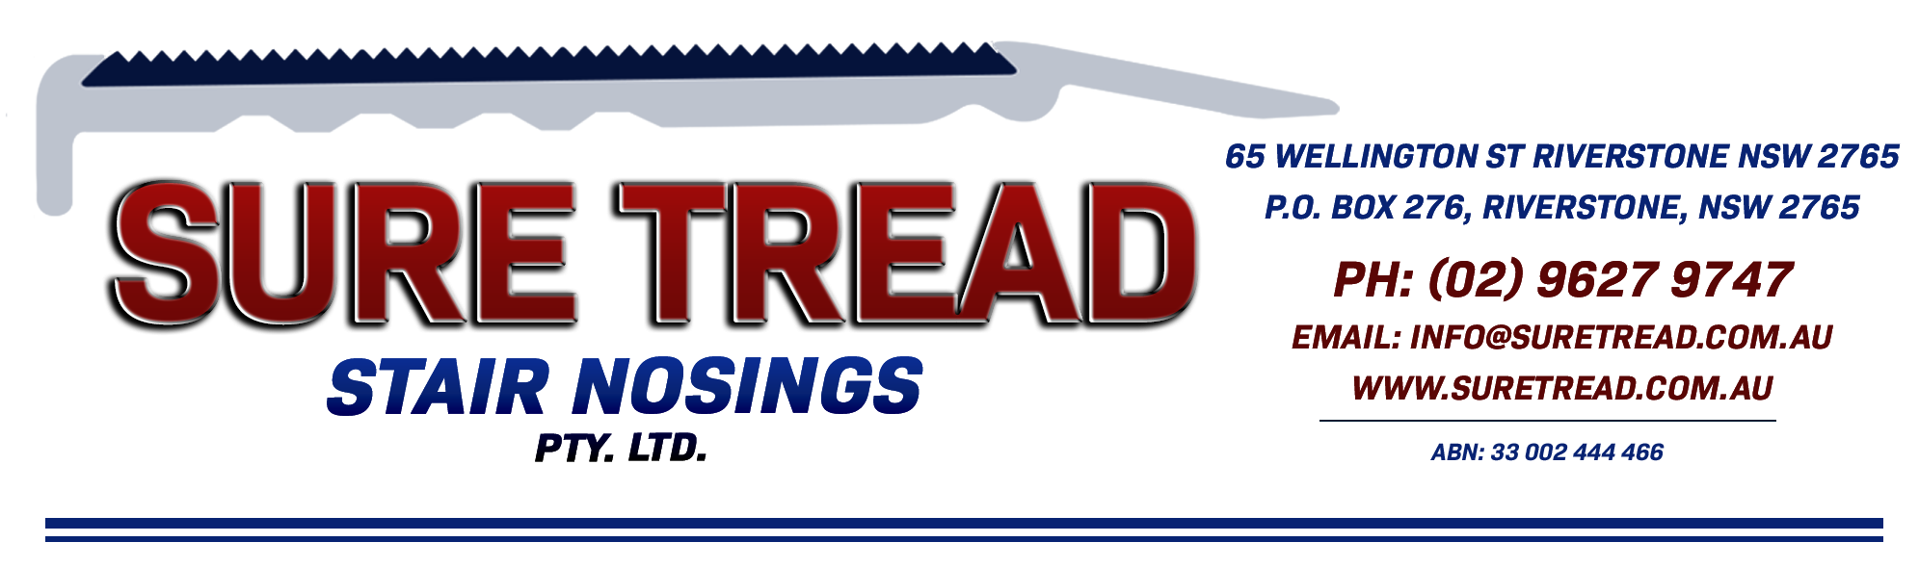
PROFILE SHEET
ST 74 SN with a 51mm Aluminium Insert
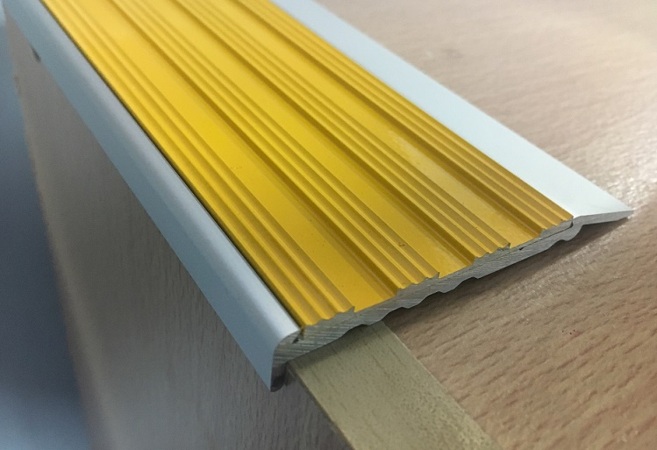
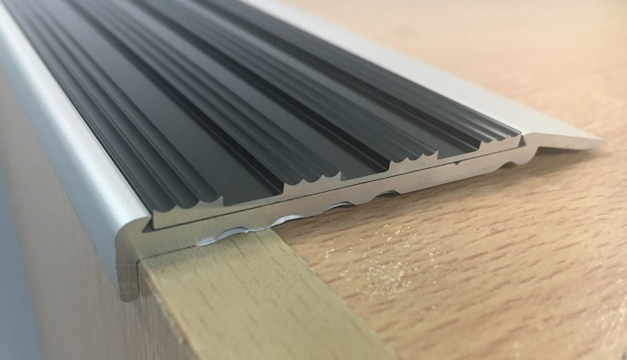

A 75mm square front clear anodised stair nosing which incorporates a 51mm Aluminium insert and has a 10mm riser.
Please Note: The underside of the riser is only 5mm.

To be fitted direct to square fronted concrete or timber steps.
Adhesive to be used under the nosing (Adhesive not supplied for a supply only)
Not suitable for soft floor coverings.
The sub floor must be in good condition (smooth, straight, level & clean)

End caps are NOT available.
Drilled at approximately 250mm spacings.
Suitable for external use.
Insert Slip Rating = P5
The Aluminium insert is available in Yellow Powder Coated, Clear Anodised, Black Anodised, Grey Powder Coated & White Powder Coated.
We recommend you seek the certifier’s approval on the profile and insert colour as they all interpret the standards differently.

